Designing for multiple screen dimensions is a difficult task on its own for simple sites. Web clients and mobile clients have drastically different standards that determine content placement, control interactions, even font size. Simple sites often struggle with mobile implementation for this reason, as it requires a redesign of the layout, whether it be simple changes to a drastic alteration of navigation elements. This is an issue the *Internet Archive™* suffers from to a large extent. The service alone is a complicated structure that contains archives of millions of elements, from books to movies and entire webpages and stores hundreds of terabytes in data. This means that the web interface has to be simplified so it is easy to navigate for researchers or casual viewers. In some sectors, the *Internet Archive™* team does a good job at designing the web interface. However, when shrinking to different device screens, the design falls apart rapidly, and their mobile app makes no attempt to the design failures. Our design is focused for a casual researcher that is trying to find a quote inside a book or news article they only partially remember. They have general technological skills to navigate documents, but not a deep understanding of the technologies *Internet Archive ™* uses. It is not their first rodeo and is capable of navigating difficult websites, but they follow standard practice and will avoid sites that suffer greatly from design flaws, untrustworthy design, or has provably incorrect information. We selected for four screens, those being the main page, the blog page, the advanced search page, and the “viewer” page.

It is crucial I explain why I believe the web version on smaller screens fail and why the mobile app makes no attempt to fix this, as it helps explain the methodology towards the redesigns. Figure 1 shows the current implementation of the smaller screen user interface. It follows basic principles that are consistent with most mobile implementations, including the shrinking of the navbar (Navigation bar) into the “hamburger” menu, the simplification of the user account segment into a single button instead of two separate buttons for logging in and signing up for an account. However, it does not consistently implement other standard design principles that smaller screens benefit from, including scaling up text boxes and buttons to make it easier to press upon elements. It keeps the terms of service at the bottom of the screen at all times, which is an important document, but not helpful nor crucial to have always at the bottom of the screen. It also has the *Wayback Machine™* at the top of the screen. While it is a common access pattern from the archive, it takes up crucial space that blocks from seeing the actual search bar that gets pushed lower on the screen (Figure 2). Figure 2 shows the design on an iPhone 16 through a developer simulator for MacOS. While it does differ from the web version with button sizes, it still suffers from the points mentioned above for the shrank web version. While they do have a “standalone” mobile application, its actually just a web browser wrapper displaying the page in figures one through three, except with a requirement for having an account. It is these design fallouts that we attempt to fix.

For the sketches, I will break my explanations and criticisms into one section per page, which cover all the sketches for that page, as previous approaches to document each one individually created length problems with this document. Starting in order, the main page is the most important to create, as it is often the first thing users see when entering your page. This is the make-or-break point for your site, as if it feels off or looks improper, users will be discouraged from using the site for various reasons. While our persona has the ability to use bad websites for her goal, if our redesign removes the credibility our site requires, they will consider it a non-trustworthy source and leave. We attempted to do follow this idea throughout the main page sketches while trying to allow for easy porting to mobile devices. The main difference between the figures is the navigation bar (navbar), which I could not find a decisive idea to create. The navbar design I stuck with was featured in Figure 5, which adds a modal for selection the collection type that it shows on the main page and modifies your searches to check the selected collection first. This adds complexity and can make the site more confusing, which testing compounded. Although it proved confusing, it was stated that it was a good idea after explanation. This modal would likely require a signifier, as it does suffer from mapping issues on first glance. This design also forces the removal of most links on the navbar, which helps mobile devices have a simplified screen, but makes navigating more difficult and requires a dropdown menu or pullout menu with the rest of links that used to be present, which was not sketched. This sketch would prove fruitless for mobile design however, as such implementations would cause confusion and therefore was removed in Figure 6 and Figure 8 for a split navbar approach, which was also not used for similar confusion issues in testing. The final design would resemble normal applications for android apps, which I will combine into what I call the “Android app” design.

Moving onto the blog page, it is completely disconnected from the main page. As shown in Figure 48, the site has no resemblance of the main Archive webpage. This lack of consistency can make the blog page feel like separate entity, even though they are the same company and operated by the same people that operate the *Archive*. On first glance, I did not notice a way to be sent back to the main page, but it is present in their navbar under “archive.org”. This separation also makes archiving these articles entirely separate from the main application, requiring extra effort if the data our user is searching for exists on this page instead. Our redesigns remerged the sites while keeping a small amount of separation. As shown in Figure 16, the site shares a similar navbar, with it being unique for the page, but not significantly to create confusion. This also allows the same modal design from the main pages mobile designs to be usable for this page’s mobile design as well. Testing showed issues with Figure 14’s approach to finding new articles and the “next/previous” buttons present in Figure 16. Figure 14 tried to have older articles located at the bottom of the page similar to the way the main page has top collections at the bottom of the screen. However, this was difficult to understand and difficult to search through when attempting to find an old article. Figure 16’s approach also suffered from mapping issues, as without explanation for what next and previous meant in this context, the tester had a different assumption on what the buttons were meant to lead the user. These buttons should be explained with better labels, and the searching method should remain, as the mapping is consistent through different sites that use the natural search bar for finding articles. The final design chosen was created by my partner, which is why no further insight is present on that front.

Moving onto the search page, it is important to visualize the current design to understand the reason for the approach. Figure 24 shows the current design, which is bad, but is tolerable in the web version of the application. It has multiple fields at all times for collection type, date and date ranges, description of the content, and three custom fields. Each element is followed up by a contains dropdown to select if it considers the search with items that “has” or “has not” the data searched. Each option also has the text “AND” on the left-hand side. Below that is the JSON, CSV, XML, etc formattable search, then information regarding using the CSV, etc search. This is cluttered, too busy, and often leaves fields unused. This is worsened in mobile format, as in Figure 25, since it shoves everything into a singular column, making it gruesome to navigate and even worse to use. To add insult to injury, when clicking search, it redirects you to the normal search page with a specially formatted search query with the data you put into the advanced search page. This page is a glorified formatter, which is exasperated by the “AND” being visible on the page, as it is a command that gets added to the search query when using more than one field. This page is redundant, clunky, and is half filled with useless information. It is for that reason that our designs combine the normal search function with the advanced search function.

The search and advanced search page design being compressed into a singular page simplifies the user experience by removing the extra unnecessary step that was described above. These sketches try different approaches, with Figure 29 attempting to keep the separation of these pages to its dismay. With the failure of this design, the other ones merged the pages together and attempted to find a solid place and method for adding the advanced search feature that was functional and did not use a majority of the screen real estate for mobile designs. The approach picked at the end was shown in Figure 27, with a dropdown approach. This is similar to other sites approach to advanced searching, which removes mapping issues that could arise for trying a brand-new custom approach. Testing showed to like this approach the best, as it was seamless to input the specific information that they had present. It was also shown to be less intimidating than the original, as it has less fields by default and removes the unnecessary custom fields by default. This page was difficult to port to mobile interfaces using the same concepts, as the mobile platforms appear to have a distain towards checkboxes. This is likely due to the difficulty to press on these buttons and the repeated tapping action to zoom in on that area and introducing an unnecessary step when trying to find something specific. Figure 28 portrays this issue clearly, as the checkbox sizes have to be small to fit in line with the search bar for mapping purposes. While this is not a concern touched upon in the sketches, in implementation, it would need to be fixed, either by shrinking down the text boxes or providing a new mapping.

As with the previous section of sketches, I feel it is relevant to explain my decision for picking this specific section, considering it is technically a component of a page and not an entire page. This is a universal media viewer component, acting as the main interface with the data that was selected, regardless of if that be a book or a public domain film. This makes it easily the most important factor on individual content pages. Regardless of the content page, it is always present and the focal point that the users interact with first. This component was not designed for mobile devices and lacks factors that make it easy to map onto mobile devices. It does not support swipe gestures for mobile devices, for books specifically, pressing the black-colored area on the right or left side of the actual book page does nothing, as only pressing on that side of the page moves forward or backward through the text. For audio files, depending on the file type, it either gives a 90s themed audio software shown in Figure 46, or a modern HTML5 audio player stylized to a minimal degree. For video files, it uses the format shown in Figure 47, which has two different maximize buttons that do the same function, has a rewind button but not a forward button, although pressing right arrow on your keyboard completes the forwarding action, and has two audio sliders, which affect the same value. It also contains special buttons for casting the media for Airplay or Chromecast devices, which for most use cases, it redundant. It is for these reasons, I believe redesigning these modals counts towards the requirement. Simplifying these modals improve the rest of the associated content pages and improves the experience for all users, not just researchers. Since they are not designed for mobile devices, that is where my sketches focused their efforts towards.

The sketches for this section attempt to standardize the viewing modal, picking different components like the video player and audio player that were quite inconsistent on the current design as described above. For the audio player in Figure 36 and Figure 38, we moved towards the approach modern music applications use, with buttons for skipping and restarting alongside an information button and a repeat song button. Testing showed the information button was confusing, mainly based on placement. In practice, it would be moved to the more standard position at the top right of the screen. For the video player shown in Figure 37, it removed the duplicate information described above, instead resulting with a consistent video player that is used widely across the internet, removing all mapping issues the original contained. For the book navigating shown in Figure 39 and Figure 41, we leaned towards the Kindle approach, which allows for swiping for moving to new pages. This makes mobile reading easier, as pressing on the screen can disconnect from the feeling of reading a book. It does still offer that feature however, alongside the next and previous page buttons that exist on the website design as well. Figure 37 is an attempt at a simplified way to navigate archived webpages. The current design puts the navigation bar at the top, which is inconsistent with all other viewer modals. This design moved it back to the bottom and simplified the previous and next buttons for navigating through archive images of the page. We also added a search bar, which makes getting to a new website easier when already on a site archive image. Testing showed these viewing modals to work better than the original with less mapping issues. No complaints were presented with these designs.

For the mood board presented in Figure 49, two color design approaches were proposed, which I labeled “Old Library” and “New Library” respectively. I felt the archive could utilize a library feeling, as the site is essentially a digital library. For the “Old Library” color scheme, I leaned towards its “archive” nature, which gives off an old but grand structure with works from all generations. This approach feels grand but gives off an outdated feeling when I tried to use the color scheme, which is the opposite of what we want for casual researchers that use the design of the page to gauge its legitimacy and reliability. The “New Library” scheme adds the pops of color I believe the site needs. The page needs to feel clean, professional in the modern sense, and organized. The utilization of these colors was limited to a select few bright colors, with the rest remaining a mute version of whites and grays. In modern sites, pops of color are used to direct your attention, so overutilizing colors will make it feel chaotic and discourage users to trust the organizational skills that the archive possesses. For the font options, I did not stray too far from standard fonts, as anything over the top would degrade the trustworthiness of the page. The fonts selected have a good balance of the modern standard with a stylized ancient flare, even if the flare is hard to notice.

The *Figma™* design follows learned principles stated above with the “New Library” design schema, using the “Sedan” font for the logo text and defaulting to “JejuGothic” elsewhere, as all of the stylized fonts used in the logo text gives off the wrong feeling for the page (Figure 50). The design reeks of “Android app”, which is my best description of an app that overuses the “hamburger” menu system, which android apps tend to suffer more from than iOS apps. This, however, is the best and most straightforward approach I could think of, as most know how to navigate those types of layouts, regardless of culture and their mappings. For the viewer page and elsewhere where swiping gestures would be expected, it is envisioned to work with those gestures alongside proper button presses. The link to the Figma design document is [here](https://www.figma.com/design/2VhaSSJcn7JSwdFdTWOnOc/Internet-Archive-Redesign?node-id=0-1&t=INMBGD1ajlIaXmhG-1).

I believe the design presented in our *Figma™* design solves the problem for our persona and their scenario. They can search for the document they want on the first page, then if they need to narrow it down, use the advanced search modal to get more information entered, and view their acquired information in an easily accessible way that is standardized across the web. The websites design portrays trustworthiness and organization throughout and gives the official presentation off at first glance.

Figures

Figure : A screenshot of the window shrunk in MacOS

Figure : A screenshot of the interface on an iPhone 16 through the iOS Simulator

Figure : The same page and device as Figure 2, scrolled down to see more details

Figure : Main page sketch 1 for the web view

Figure : Main page sketch 2 for the web view

Figure : Main page sketch 3 for the phone view

Figure : Main page sketch 4 for the tablet view

Figure : Main page sketch 5 for the phone version

Figure : Main page sketch 6 mobile

Figure : Main page sketch 7 mobile

Figure : Main page sketch 8 mobile

Figure : Main page sketch 9 mobile

Figure : Main page sketch 10 mobile

Figure : Blog sketch 1 web view

Figure : Blog sketch 2 ultrawide web view

Figure : Blog sketch 3 4:3 web view

Figure : Blog sketch 4 tablet view

Figure : Blog sketch 5 phone view

Figure : Blog sketch 6 phone view

Figure : Blog sketch 7 phone view

Figure : Blog sketch 8 phone view

Figure : Blog sketch 9 phone view

Figure : Blog sketch 10 phone view

Figure : A screenshot of the current design of advanced search at the top of the page, minus the navbar

Figure : A screenshot of the current design of advanced search in a shrunk format

Figure : Sketch 1 of the Search/Advanced search page

Figure : Sketch 2 of the Search/Advanced search page

Figure : Sketch 3 of the Search/Advanced search page

Figure : Sketch 4 of the Search/Advanced search page

Figure : Sketch 5 of the Search/Advanced search page

Figure : Sketch 6 of the Search/Advanced search page

Figure : Sketch 7 of the Search/Advanced search page

Figure : Sketch 8 of the Search/Advanced search page

Figure : Sketch 9 of the Search/Advanced search page

Figure : Sketch 10 of the Search/Advanced search page

Figure : Sketch 1 of the viewer modal

Figure : Sketch 2 of the viewer modal

Figure : Sketch 3 of the viewer modal

Figure : Sketch 4 of the viewer modal

Figure : Sketch 5 of the viewer modal

Figure : Sketch 6 of the viewer modal

Figure : Sketch 7 of the viewer modal

Figure : Sketch 8 of the viewer modal

Figure : Sketch 9 of the viewer modal

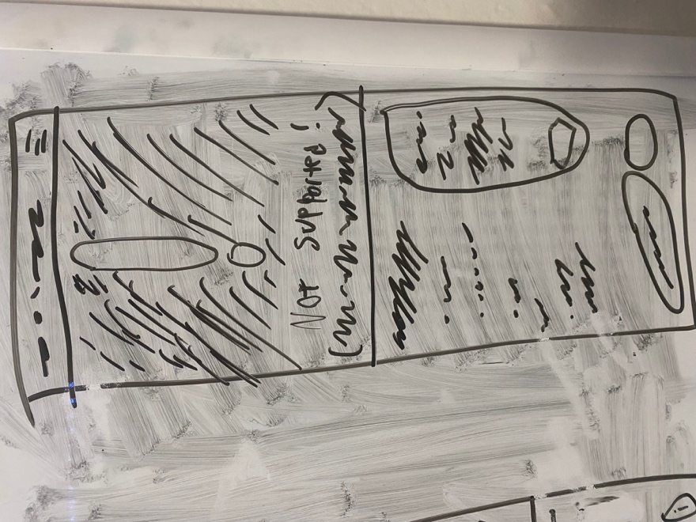

Figure : Sketch 10 of the viewer modal

Figure : Older style encoder present on some file types uploaded to the archive

Figure : Video player present in the archive

Figure : A screenshot of the current Archive blog page

Figure : The mood board created for this project

Figure : Figma Mobile Layout for every page besides the blog

